
Department of Engineering Technology
Foundation University Islamabad
School of Science and Technology

Course: Introduction to Web Technology Lab
Lab I Manual
Name:
Roll no:

Topic: Development Environment Setup & First Web Page
Performance |  |  | Lab Report
Description | Total Marks | Marks Obtained | Description | Total Marks | Marks  Obtained
Practical Setup and Configuration | 5 |  | Report | 5
Total Marks obtained

Lab Objective:
- Download and install Visual Studio Code (VS Code)
- Understand and verify Node.js and NPM installation
- Install and manage NPM packages for a project
- Use Google Chrome DevTools for debugging and testing
Software & System Requirements
Requirement | Description
Operating System | Windows 10/11 MacOS / LINUX
Internet | Required for Downloads
Web Browser | Google Chrome (latest Version)
Storage | Minimum 2 Gb Free Space

Step1: Installing Visual Studio Code (VS Code)
- Open Google Chrome
- Go to this website:
https://code.visualstudio.com
- Click on Download for Windows / macOS / Linux
- Wait for the installer file to download
Step 2: Install VS Code (Windows)
- Open the downloaded file: VSCodeSetup.exe
- Click Next
- Accept the license agreement
- Click Next
- Select Destination Folder (default is recommended)
- Check these boxes:
  - ✅ Add to PATH
  - ✅ Create Desktop Icon
- Click Install
- Click Finish

Step 3: Install Important Extensions
Click the Extensions Icon (left sidebar) and install:
Extension Name | Purpose
Live Server | Runs HTML Page in Browser
Prettier | Code Formatting
ES7 + React Snippets | React ShortCuts
GitLens | GitSupport

PART 2: Installing Node.js and NPM
Step 1: Download Node.js
- Go to:
https://nodejs.org
- Download LTS Version
- Open the downloaded file
Step 2: Install Node.js
- Click Next
- Accept license
- Keep default settings
- Click Install
- Click Finish
Step 3: Verify Installation
- Open Command Prompt
- Type:
Commands:
- node -v
- npm -v
If version numbers appear, installation is successful.
PART 4: Installing Google Chrome DevTools
Step 1: Install Google Chrome
- Go to:
https://www.google.com/chrome
- Download and install Chrome
What is Chrom DevTools?
Chrome DevTools helps developers:
- Inspect HTML & CSS
- Debug JavaScript
- Test mobile responsiveness
- Monitor network requests
Step 2: Open DevTools
- Open Chrome and press:
  - F12
  - OR
  - Right Click: Inspect
Step 3: Explore DevTools Tabs
Tab | Purpose
Elements | View HTML & CSS
Console | View Errors & Logs
Network | Monitor API Calls
Application | Storage, Cookies, Local Storage
Lighthouse | Performance Testing
PART 5: HTML Basic Structure
Step 1: Create Project Folder
- Open VS Code
- Click File - Open Folder
- Create a new folder named:
Web-Lab-01
- Open this folder in VS Code
Step 2: Create HTML File
- Right-click inside VS Code Explorer
- Click New File
- Name it: “index.html”
3: Write Basic HTML Structure
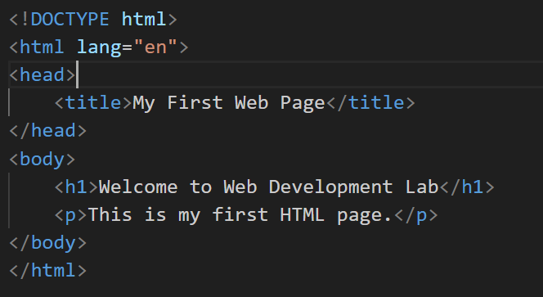
Step 4: Run Using Live Server
- Right-click on index.html
- Select Open with Live Server
- Page opens in Google Chrome

Lab Report Guidelines
Report Format and Sections:
I. Installation Steps
- Describe the steps taken to install and set up Vs Code and its extensions and Node Js.
- Include any problems faced and how you resolved them.
- Provide relevant screenshots of the installation or setup process.
Additional General Tips for Students:
- Make sure your report is well-organized and easy to follow.
- Use proper headings for each section mentioned above.
- Include screenshots wherever required to demonstrate progress and outputs including Figure Captions.
- Explain commands and outputs in simple and clear language.
- Submit the lab report as a document file (Only Word)
- In next Lab You must Submit your Previous lab Report in Printed Form

